**ONLINE EXAM SYSTEM**

Exam Software is a Test Management Software, which offers a complete solution for Computer Based Test (CBT) .They are used to set up multiple choice tests  for set time periods that when submitted are automatically corrected and the results logged beside the student's reference number.

ONLINE EXAM UI DESIGN:

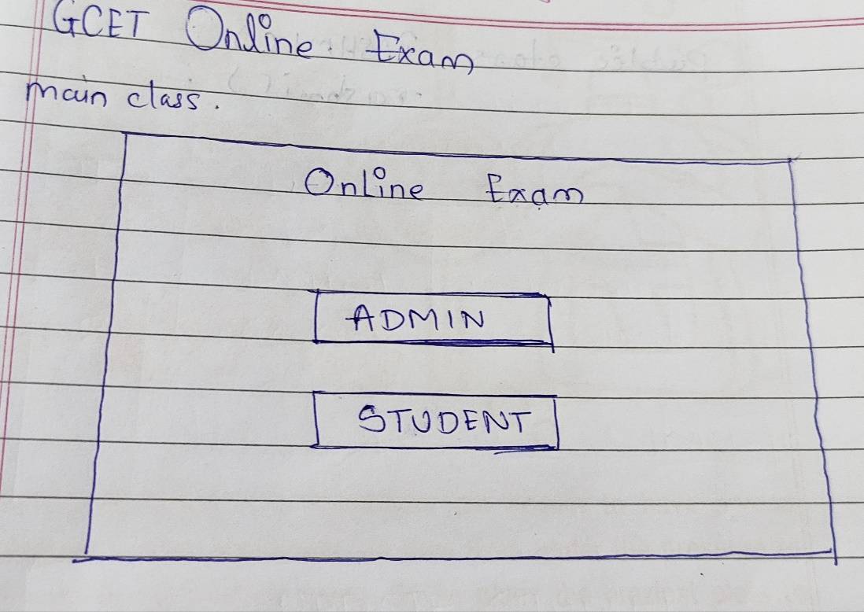

CLICK Admin:

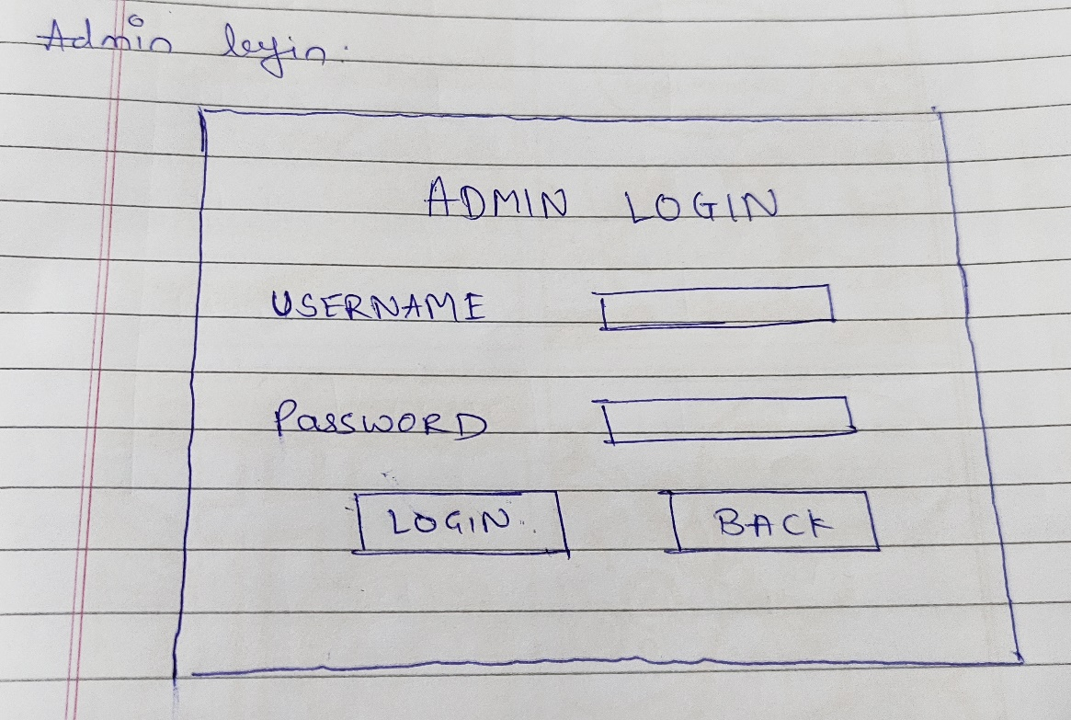

After login Admin Section Form open:

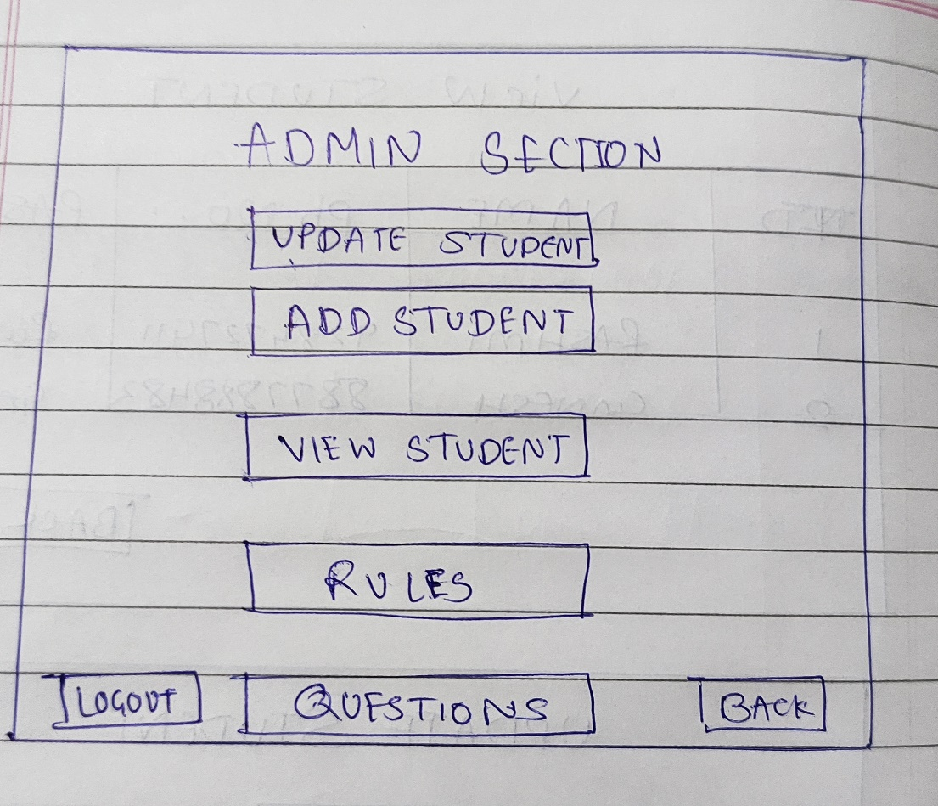

Add Student:

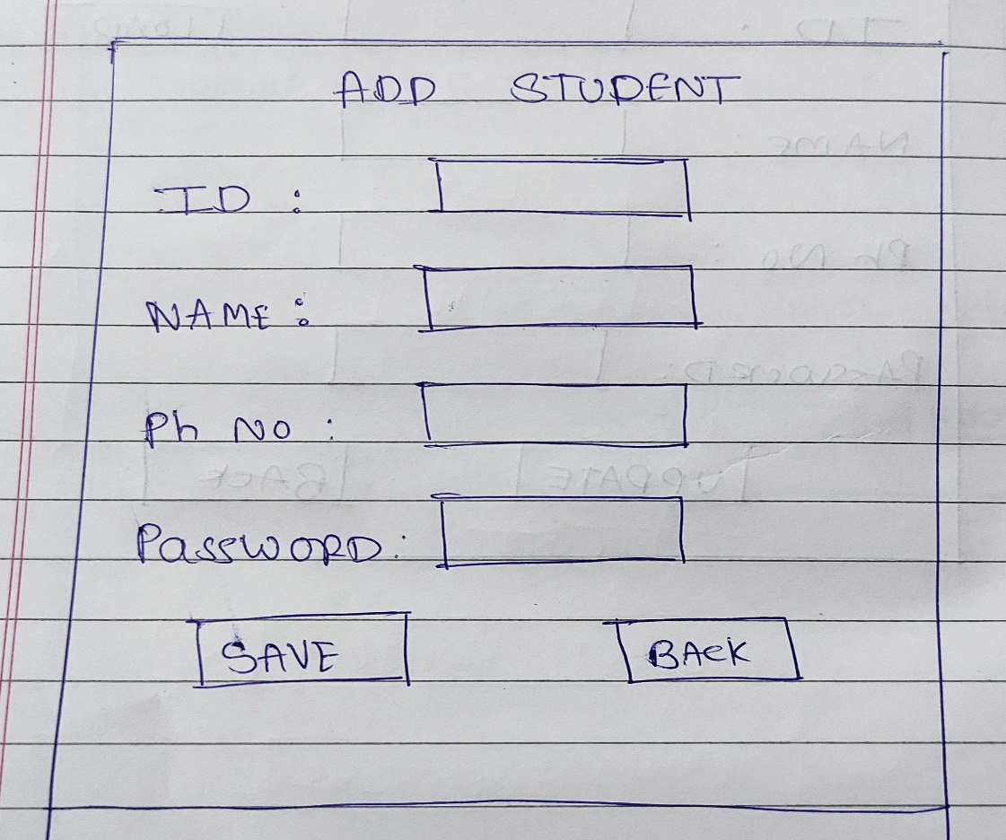

View Student:

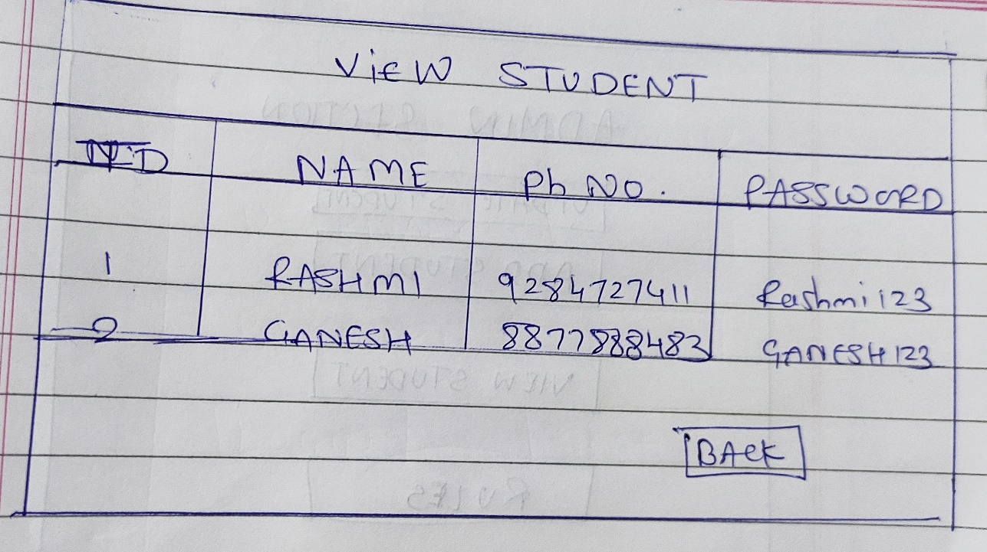

Update Student:

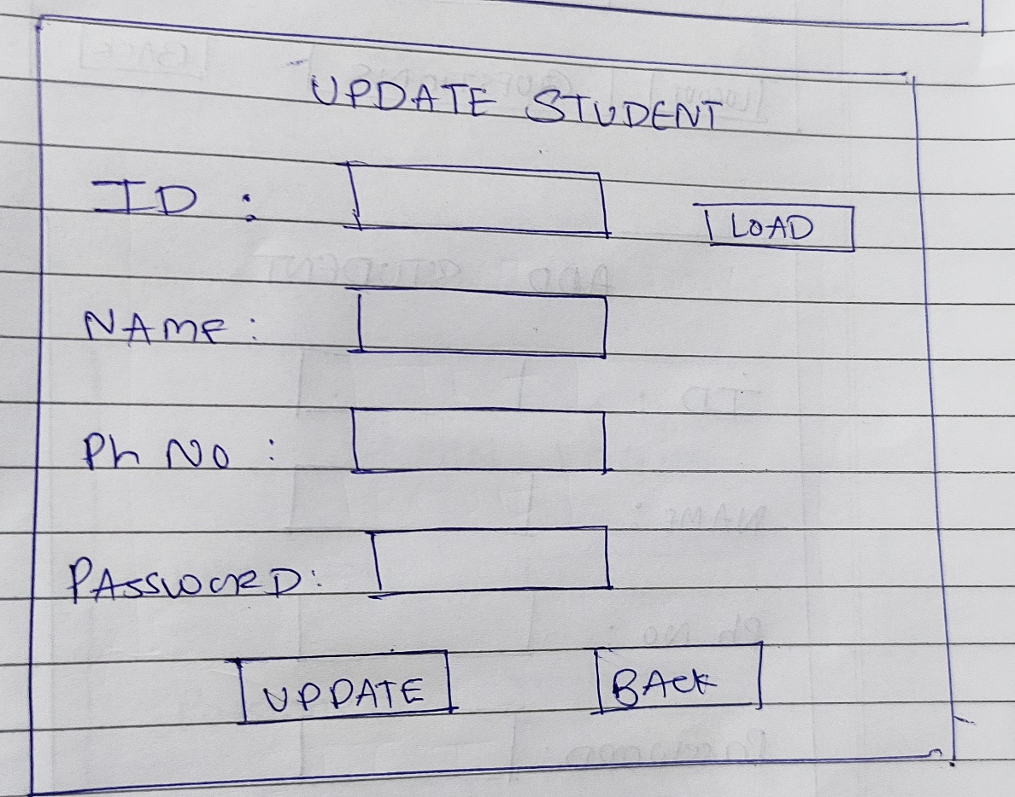

Rules:

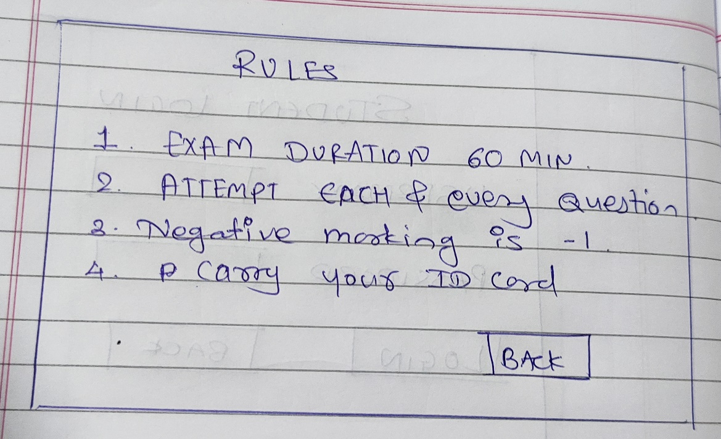

Question Paper:

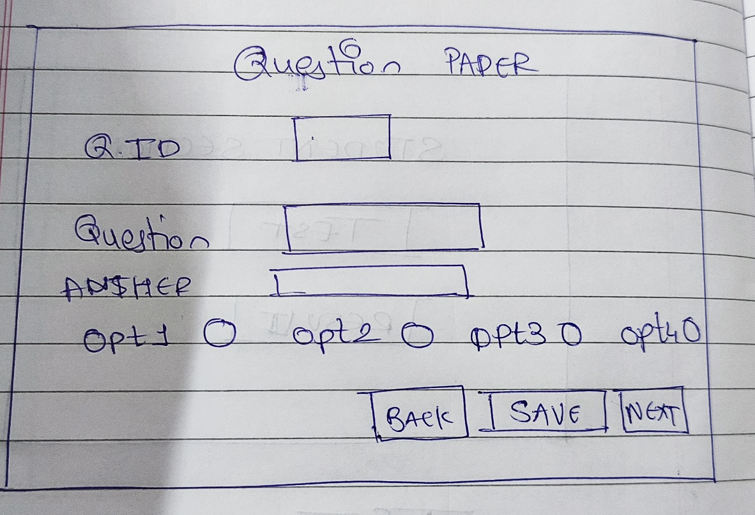

Student Login:

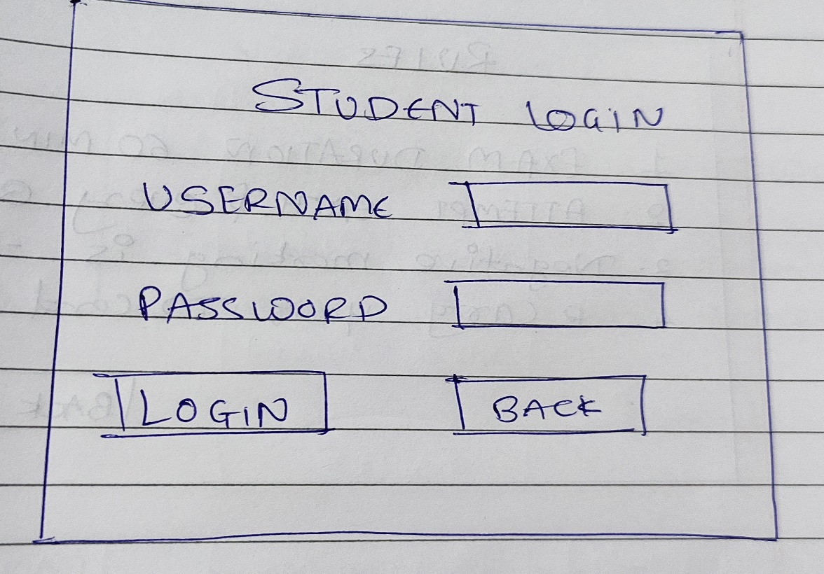

Student Section:

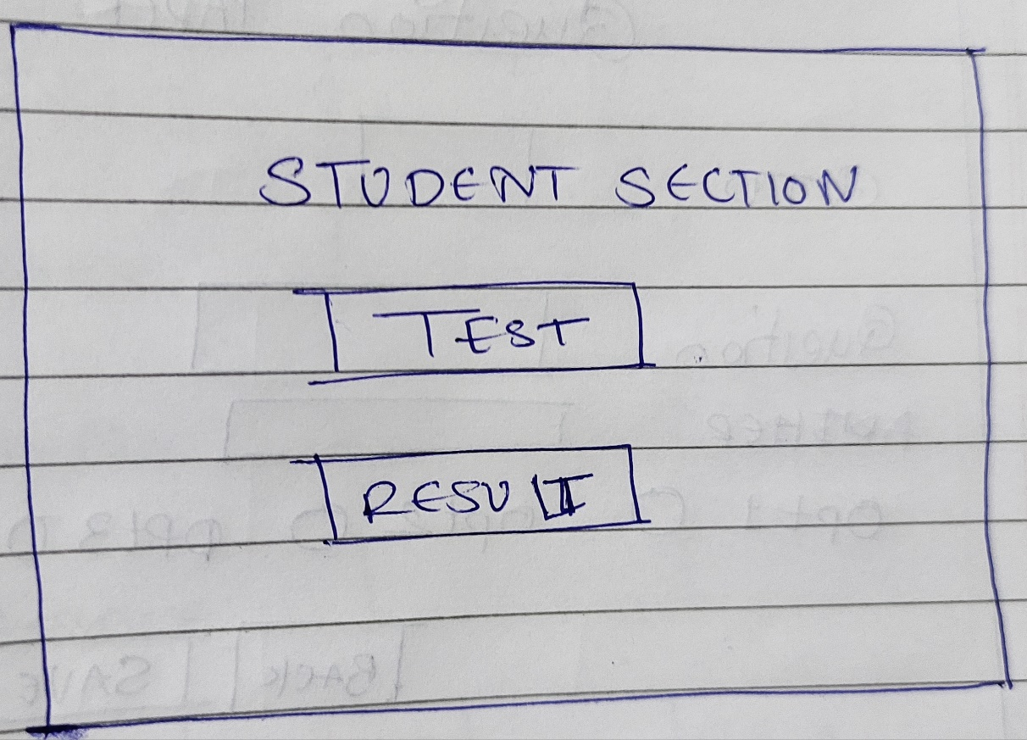

Click on Test:

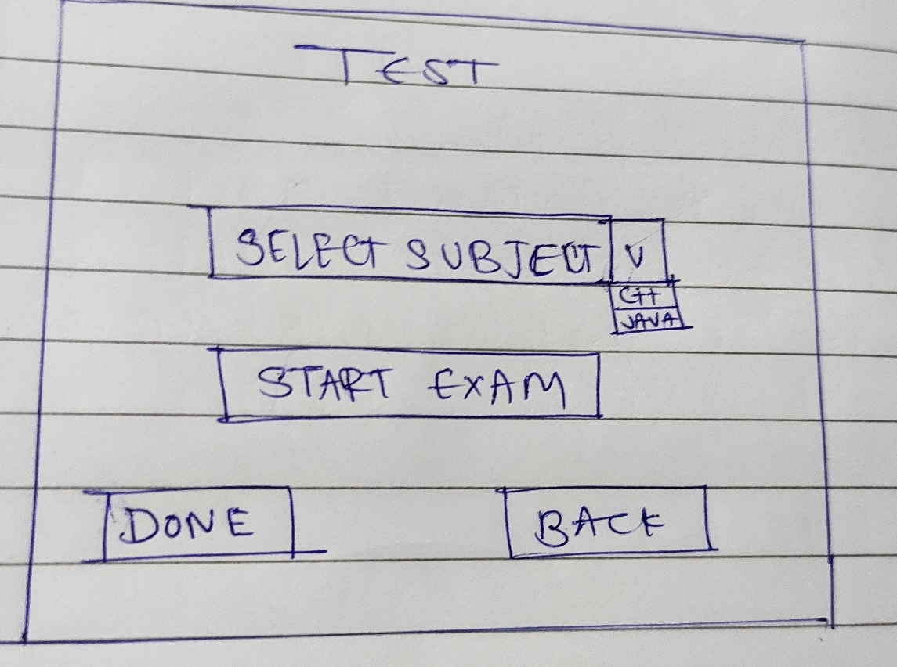

Select exam mode.

Click on start exam:

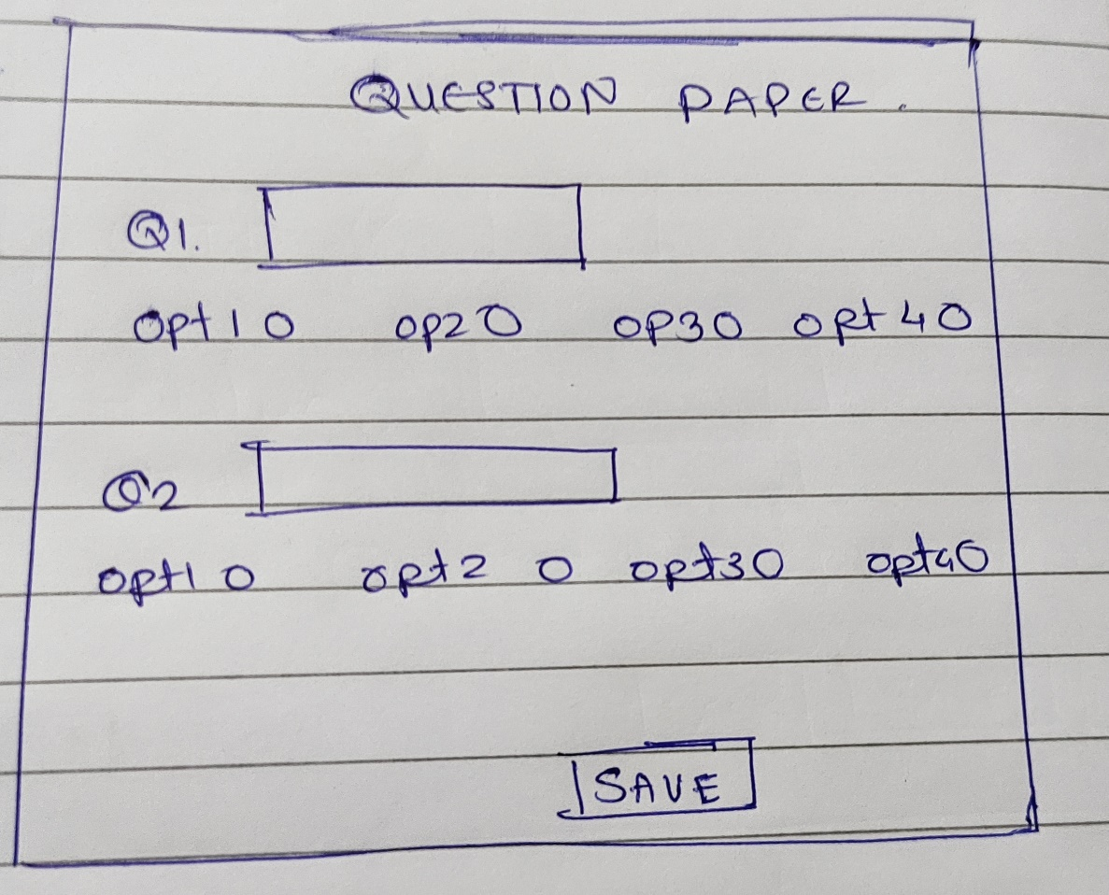

Click on result:

